I’m pleased to inform you all that Nottinghamshire County Council have now moved all training for foster arers to the new ‘My Learning My Career’ portal. My Learning My Career offers a one stop shop service for all our foster carers to learn anytime, anywhere using desktop and mobile devices.

My Learning My Career includes a host of features to make it easier to:

* search through online (e-learning) and face-to-face courses
* save your chosen courses to learn at your own pace
* review your completed learning and development courses.

To ensure you can start booking yourself onto training you will be required to create an account. It is important to note that each account will be unique to each person, therefore if there is a secondary carer within your household it is essential that they create their own account.

If you have any issues following the steps below please contact our training team who will be happy to support you: **0115 993 9319**

Please follow the steps below on **‘how to create your own account’**:

* Please click here <https://nottscc.learningpool.com/login/index.php>
* Once the page has opened please click the cid:image003.jpg@01D47C3D.2AD52CD0 button. This will display a new account sign up form.
* Add your email *(take note of this, as this will be your username)*.
* Add your password *(The password must have at least eight characters, at least one lower case letter)*
* On the same form please complete the ‘More Details’ section, again add your email address, first name and last name.
* Under the section **‘Registration Key’** please enter the number **348157**. *(This will ensure you are set up as a foster carer and all foster carer training is available for you to view and book on)*
* Once you have entered the registration Key, please click cid:image006.jpg@01D47C3D.2AD52CD0
* If you have completed this form successfully, you will see the below screen…

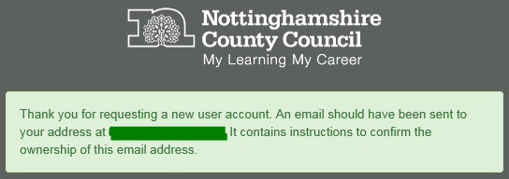

Following this you should receive an email to your provided email account stating the following. Confirm your request by clicking the link provided and you will be ready to go!

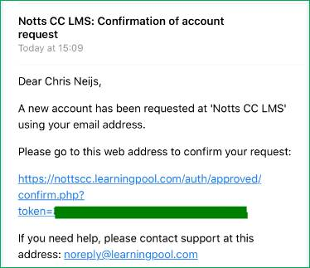



Once you confirm your request by clicking the link provided you will be presented with the below screen, click the cid:image011.png@01D47C31.0A244D60 button and login using your username (email address) and password.

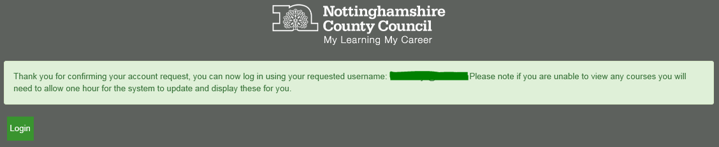

Desktop version – as it will appear on your computer (Click here for the mobile version or scroll down)

To start booking yourself on training click the **‘Course Search’** button

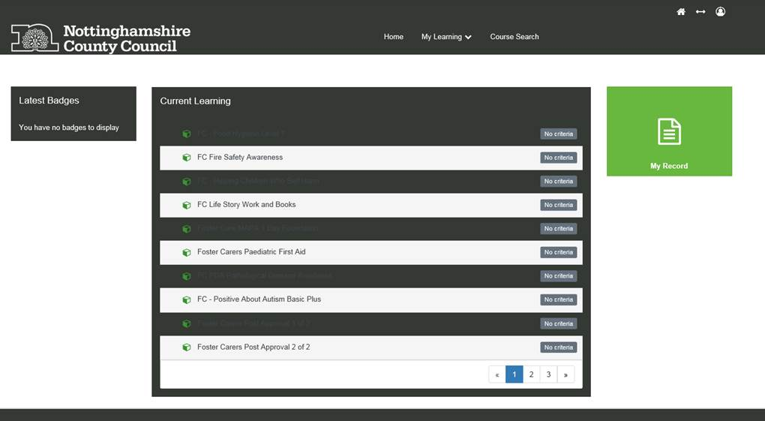

You will now see a list of **‘categories’**, on the left hand side of your screen you should see the following:

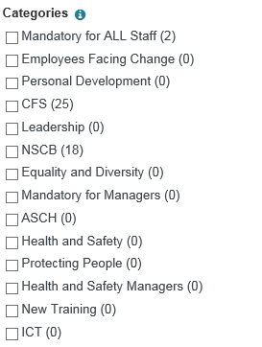

Click the square next to the category **‘CFS (25)’** and this will display all available training events for you to book yourself on.

Clicking the square next to the category **‘NSCB (18)’**, will show you all available e-learning training programmes you can complete from the comfort of your own home. Please note e-learning is an internet based learning programme, which is also smart phone friendly (i.e. can be used on iPhones, iPads, tablets etc.).

On finding a training event you wish to book yourself on, click the course name

cid:image020.png@01D47C36.61673920

Once you have clicked the course title you will see the course information page, on this page scroll down to the bottom and you will see the following.

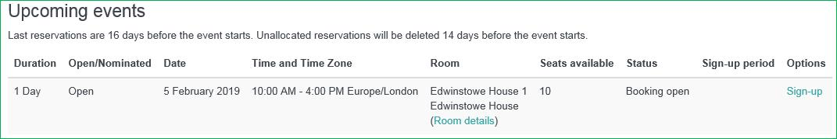

To book yourself a place on the training click the **‘Sign-up’** link

On clicking **‘Sign-up’** you will beasked to complete the following sections:

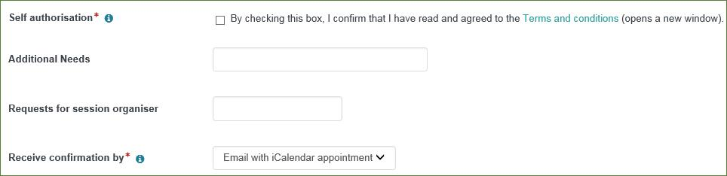

Once completed click the cid:image027.png@01D47C37.93B1DE20 button to confirm your booking.

You should receive an email confirming your booking.

**Mobile Version – as it will appear on your mobile phone**

To start booking yourself on training click here



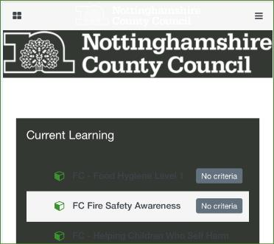

This will open the below page, once open click the **‘Course Search’** option.

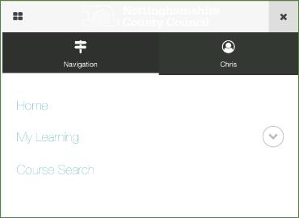

You will now see a list of **‘categories’** like the below:

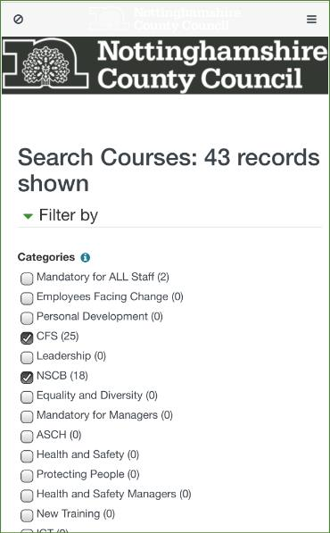

Click the square next to the category **‘CFS (25)’** and this will display all available training events for you to book yourself on.

Clicking the square next to the category **‘NSCB (18)’** will show you all available e-learning training programmes you can complete from the comfort of your own home. Please note e-learning is an internet based learning programme, which is also smart phone friendly (i.e. can be used on iPhones, iPads, tablets etc.).

Once you have clicked a category push up to find all available training events

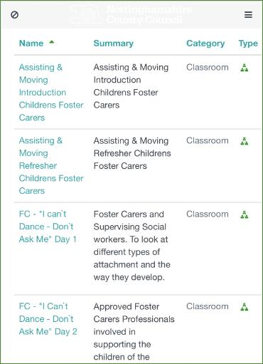

On finding a training event you wish to book yourself on, click the course name, you will now see the course information page, on this page push up to the bottom of the page and you will see the following.

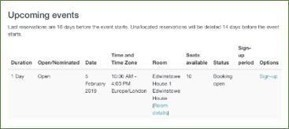

To book yourself a place on the training click the **‘Sign-up’** link. *(you may require to scroll to the right hand side of the screen if your screen is zoomed in)*

On clicking **‘Sign-up’** you will beasked to complete the following sections:

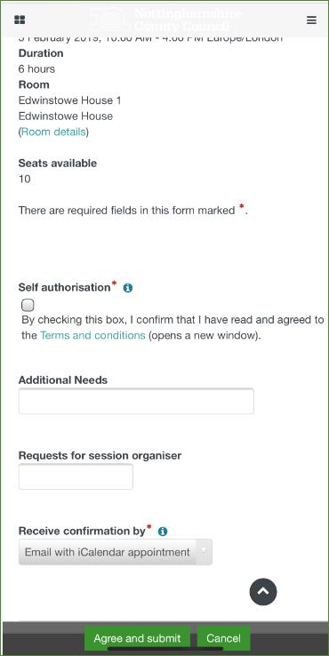

Once completed click the cid:image027.png@01D47C37.93B1DE20 button to confirm your booking.

You should now receive an email confirming your booking.

If you have any issues following the steps above please contact our training team who will be happy to support you: **0115 993 9319.**